Session plan Template
- See page 4 for an example.

EXAMPLE SESSION PLAN
Date: | Sport: | Duration/Time:
Participants: | Session Topic: | Equipment:
Goals + Learning Outcomes | Goals:  Learning Outcomes:
Health and Safety Concerns
Coaching Style
Division of Tasks

INTRODUCTION AND WARM-UP
Introduction:  Warm-Up Activity:  (diagram) | Setup/Execution:  Coaching Points:  Challenge: | Time –  Coaching Roles:

MAIN
Activity/Game:  (diagram)  Activity/Game 2:  (diagram) | Setup/Execution:  Coaching Points:  Challenge:  Setup/Execution:  Coaching Points:  Challenge: | Time –  Coaching Roles:  Coaching Roles:

COOL-DOWN
Cool-Down Activity:  (diagram)  Debrief: | Setup/Execution:  Coaching Points:  Challenge: | Time –  Coaching Roles:

EXAMPLE SESSION PLAN – Switching Play
Date: January 18, 2023 | Sport: Soccer | Duration/Time: 40 minutes
Participants: 12-13 aged 18+ | Session Topic: Switching Play | Equipment: 13 dots or cones, 2 nets, 8 balls
Goals + Learning Outcomes | Goals:  -> Have fun. Learn how to switch the play effectively, including the use of speed afterward, taking advantage of over-compact defenses, maintaining width and  Learning Outcomes: (Switching Play)  -> Maintaining width to take advantage of over-compact defensive structures.  -> Use of central players (maybe even a neutral) to switch the play.  -> Activation of speed and look to create overloads immediately after the switch through overlapping and underlapping runs.
Health and Safety Concerns | Cones as a potential sliding risk, nets as a potential falling risk.

Introduction and WARM-UP
Introduction:  - Learn names, complete safety check of participants and area, introduce session topic and key learning outcomes.  - Challenges might be rewards, they might be adaptations, modifications, motivating words to participants.  Warm-Up Activity:  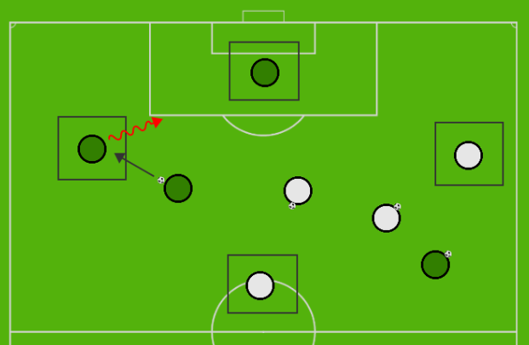 | Setup/Execution: 4 players start set up in the squares. Players must pass and move to find an open player in the square, where they then take their place. 8 balls for 12 players. Integrate some dynamics into the players w/o the ball.  Progression: 4 players now act as defenders. If you lose the ball, you become a defender. Then progress into two teams 4v4 + 4 with a permanent defensive team of four. Which teams can free up all four squares the fastest?  Coaching Points:  - Finding the right angle and opportunity to switch play, even in a crowded area.  Challenge:  - Divide the team up by placing a pinnie on the ground. Who can get there the fastest will decide the three teams of four. Then which team can be the team of four that wins it the fastest by getting all four of the outside players into the game. | Time –  12 total  4 mins  4 mins  4 mins  Coaching Roles:

MAIN
Activity/Game:  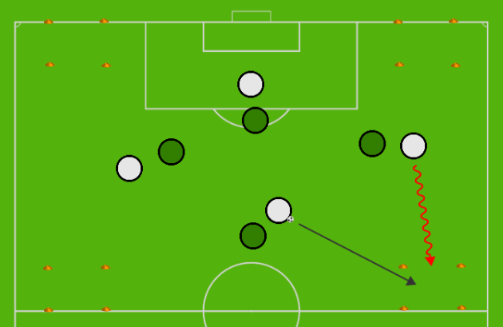  Activity/Game 2: 6v6  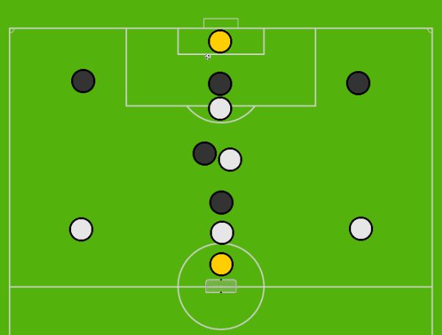 | Setup/Execution:  6v6 now using the width of the gym. One dot in the centre that is added in eventually. Can you score by a pass into the square, and then keep possession.  Coaching Points:  - Focus is on switching play when one side becomes congested, maintaining that width, and activating speed after the switch.  - Tip the balance in your favour if needed to make it that you need to have four defenders on the side of the ball.  Challenge (as a progression):  - A switch before the halfway mark followed by a goal = 3 points.  Setup/Execution:  6v6 game bringing out the principles of play, while keeping much in the way of width, more than usual for small-sided soccer.  Coaching Points:  -> Maintaining width to take advantage of over-compact defensive structures.  -> Use of central players (maybe even a neutral) to switch the play.  -> Activation of speed and look to create overloads immediately after the switch through overlapping and underlapping runs.  Challenge:  -> Goal 5-6 seconds after switch of play before half is going to be worth 3 points. | Time –  12 mins  Coaching Roles:  Time:  - 10 mins

COOL-DOWN
Cool-Down Activity:  Debrief:  - | Setup/Execution: 4 players start set up in the squares. Players must pass and move to find an open player in the square, where they then take their place. 8 balls for 12 players. Integrate some dynamics into the players w/o the ball, followed by static stretching. Tell someone your favourite part of the session, your name, and something you learned today. | Time –  2-5 mins  Coaching Roles:

EXAMPLE SESSION PLAN – Progressive Possession
Date: January 18, 2023 | Sport: Soccer | Duration/Time: 40 minutes
Participants: U12-U13 | Session Topic: Progressive Possession | Equipment: 13 dots or cones, 2 nets, 8 balls
Goals + Learning Outcomes | Goals:  -> Have fun. Learn how to switch the play effectively, including the use of speed afterward, taking advantage of over-compact defenses, maintaining width and  Learning Outcomes: (Switching Play)  -> Maintaining width to take advantage of over-compact defensive structures.  -> Use of central players (maybe even a neutral) to switch the play.  -> Activation of speed and look to create overloads immediately after the switch through overlapping and underlapping runs.
Health and Safety Concerns | Cones as a potential sliding risk, nets as a potential falling risk.

Introduction and WARM-UP
Introduction:  - Learn names, complete safety check of participants and area, introduce session topic and key learning outcomes.  - Challenges might be rewards, they might be adaptations, modifications, motivating words to participants.  Warm-Up Activity: | Setup/Execution: 4 players start set up in the squares. Players must pass and move to find an open player in the square, where they then take their place. 8 balls for 12 players. Integrate some dynamics into the players w/o the ball.  Progression: 4 players now act as defenders. If you lose the ball, you become a defender. Then progress into two teams 4v4 + 4 with a permanent defensive team of four. Which teams can free up all four squares the fastest?  Coaching Points:  - Finding the right angle and opportunity to switch play, even in a crowded area.  Challenge:  - Divide the team up by placing a pinnie on the ground. Who can get there the fastest will decide the three teams of four. Then which team can be the team of four that wins it the fastest by getting all four of the outside players into the game. | Time –  12 total  4 mins  4 mins  4 mins  Coaching Roles:

MAIN
Activity/Game:  Activity/Game 2: 6v6 | Setup/Execution:  6v6 now using the width of the gym. One dot in the centre that is added in eventually. Can you score by a pass into the square, and then keep possession.  Coaching Points:  - Focus is on switching play when one side becomes congested, maintaining that width, and activating speed after the switch.  - Tip the balance in your favour if needed to make it that you need to have four defenders on the side of the ball.  Challenge (as a progression):  - A switch before the halfway mark followed by a goal = 3 points.  Setup/Execution:  6v6 game bringing out the principles of play, while keeping much in the way of width, more than usual for small-sided soccer.  Coaching Points:  -> Maintaining width to take advantage of over-compact defensive structures.  -> Use of central players (maybe even a neutral) to switch the play.  -> Activation of speed and look to create overloads immediately after the switch through overlapping and underlapping runs.  Challenge:  -> Goal 5-6 seconds after switch of play before half is going to be worth 3 points. | Time –  12 mins  Coaching Roles:  Time:  - 10 mins

COOL-DOWN
Cool-Down Activity:  Debrief:  - | Setup/Execution: 4 players start set up in the squares. Players must pass and move to find an open player in the square, where they then take their place. 8 balls for 12 players. Integrate some dynamics into the players w/o the ball, followed by static stretching. Tell someone your favourite part of the session, your name, and something you learned today. | Time –  2-5 mins  Coaching Roles:



